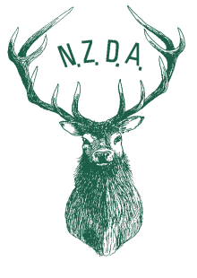

To all NZDA branches 4 August 2017
Consultation opens for proposed (2018) TB Free Pest Control Operations
Branches are urged to participate in the consultation process
Back ground
- OSPRI has a goal supported by government of eliminating bovine TB
- OSPRI has advised details of proposed TB FREE Pest Control Operations for 2018
- These operations involve both ground and aerial use of 1080.
- Both NZDA and GAC oppose the use of poisons when such use affects game animals.
- Both NZDA and GAC have strenuously urged OSPRI to engage in a process of consultation to
- identify areas and game populations that are important to hunters
- seek changes to operations to mitigate adverse effects on game populations.
- NZDA and GAC acknowledge that OSPRI has made moves to meet hunters’ concerns
Moving forward
OSPRI has provided a process for consultation with the initial national consultation ending at the end of September.
NZDA branches are urged to make submissions particularly in respect to operations in their areas where the branch will have the benefit of local knowledge.
Branches are urged to provide early draft copies of submissions to National Office so that Natex is aware of local concerns.
Branch engagement in the consultation process in this early national phase will register branch interest in being consulted at regional and local phases.

Bill O’Leary
National President.

